Jesus Nolazco

Chapter 13 Assignment

**Page 359 What’s the Difference? Middle**

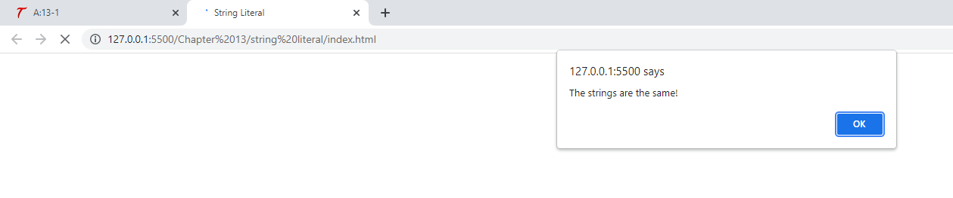

<!DOCTYPE html>

<html lang="en">

<head>

    <title>String Literal</title>

</head>

<body>

    <script src="app.js"></script>

</body>

</html>

let guitar_string1 = "E";

let guitar_string2 = "E";

if (guitar_string1 === guitar_string2) {

    alert("The strings are the same!");

} else {

    alert("The strings are not the same!");

}

**Page 359 What’s the difference? Bottom**

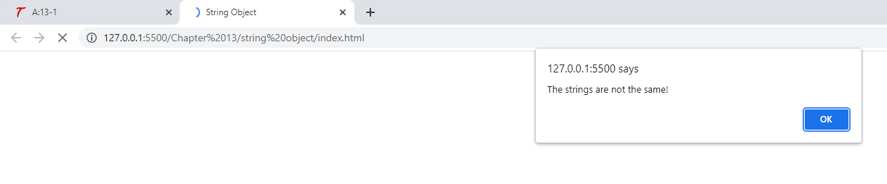

<!DOCTYPE html>

<html lang="en">

<head>

    <title>String Object</title>

</head>

<body>

    <script src="app.js"></script>

</body>

</html>

let guitar_string1 = new String("E");

let guitar_string2 = new String("E");

if (guitar_string1 === guitar_string2) {

    window.alert("The strings are the same!");

} else {

    window.alert("The strings are not the same!");

}

**Page 360 length property**

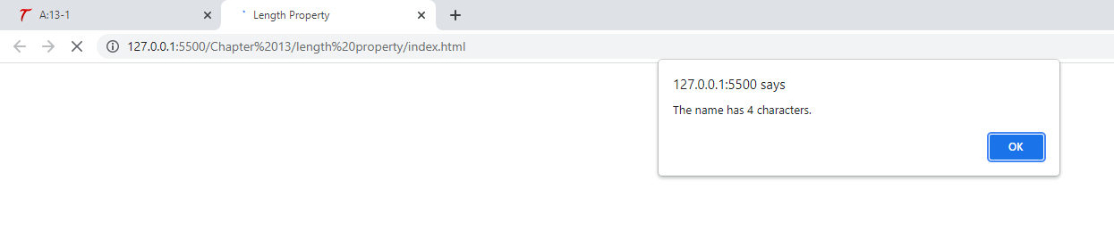

<!DOCTYPE html>

<html lang="en">

<head>

    <title>Length Property</title>

</head>

<body>

    <script src="app.js"></script>

</body>

</html>

let myname = "John";

alert("The name has " + myname.length + " characters.");

**Page 361 charAt()**

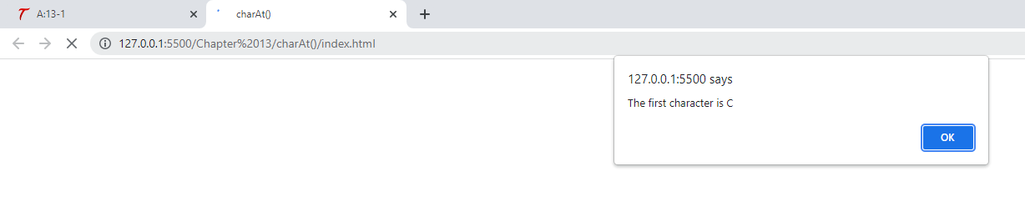

<!DOCTYPE html>

<html lang="en">

<head>

    <title>charAt()</title>

</head>

<body>

    <script src="app.js"></script>

</body>

</html>

let the_text = "Character";

let first_char = the_text.charAt(0);

alert("The first character is " + first_char);

**Page 362 Last character**

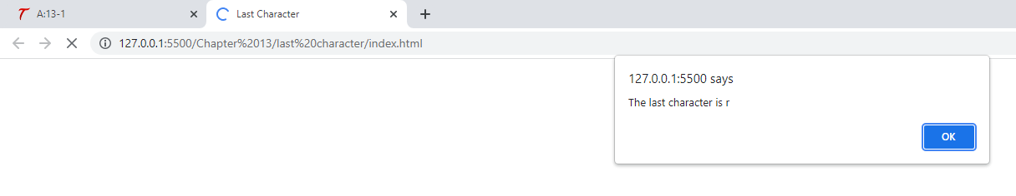

<!DOCTYPE html>

<html lang="en">

<head>

    <title>Last Character</title>

</head>

<body>

    <script src="app.js"></script>

</body>

</html>

let the_text = "Character",

    position = the_text.length - 1,

    last_char = the_text.charAt(position);

alert("The last character is " + last_char);

**Page 362 concat()**

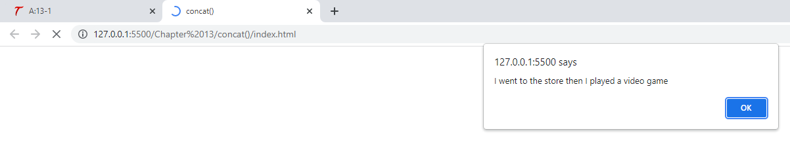

<!DOCTYPE html>

<html lang="en">

<head>

    <title>concat()</title>

</head>

<body>

    <script src="app.js"></script>

</body>

</html>

let string1 = "I went to the store ",

    string2 = "then ",

    string3 = "I played a video game";

alert(string1.concat(string2, string3));

**Page 363 slice()**

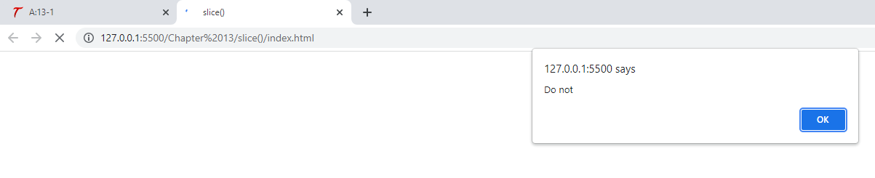

<!DOCTYPE html>

<html lang="en">

<head>

    <title>slice()</title>

</head>

<body>

    <script src="app.js"></script>

</body>

</html>

let the_text = "Do not cut this short!";

let shorter_string = the_text.slice(0, 7);

alert(shorter_string);

**Page 363 substring()**

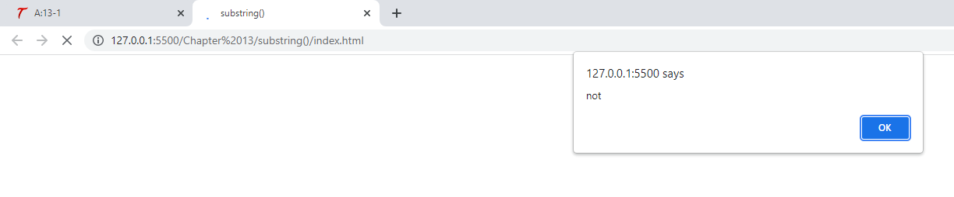

<!DOCTYPE html>

<html lang="en">

<head>

    <title>substring()</title>

</head>

<body>

    <script src="app.js"></script>

</body>

</html>

let the_text = "Do not cut this short!";

let shorter_string = the_text.substring(3, 7);

alert(shorter_string);

**Page 364 localcompare()**

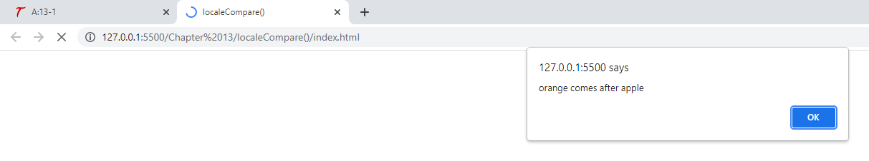

<!DOCTYPE html>

<html lang="en">

<head>

    <title>localeCompare()</title>

</head>

<body>

    <script src="app.js"></script>

</body>

</html>

let comp_string = "orange",

    new_string = "apple",

    pos = comp_string.localeCompare(new_string);

if (pos < 0) {

    alert(comp_string + " comes before " + new_string);

} else if (pos > 0) {

    alert(comp_string + " comes after " + new_string);

} else {

    alert("The strings are equal");

}

**365 indexOf() – C**

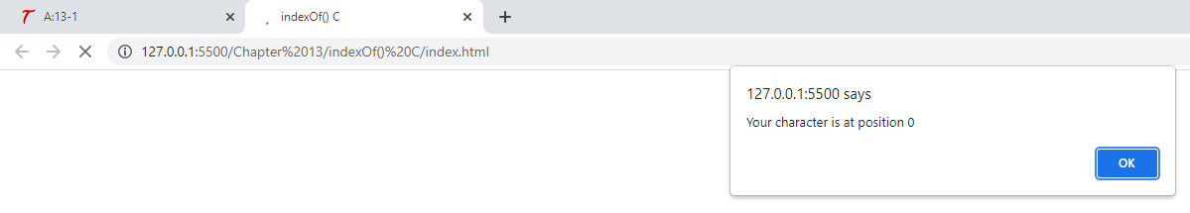

<!DOCTYPE html>

<html lang="en">

<head>

    <title>indexOf() C</title>

</head>

<body>

    <script src="app.js"></script>

</body>

</html>

let the_text = "Cool";

let position = the_text.indexOf("C");

alert("Your character is at position " + position);

**Page 365 indexOf() – c**

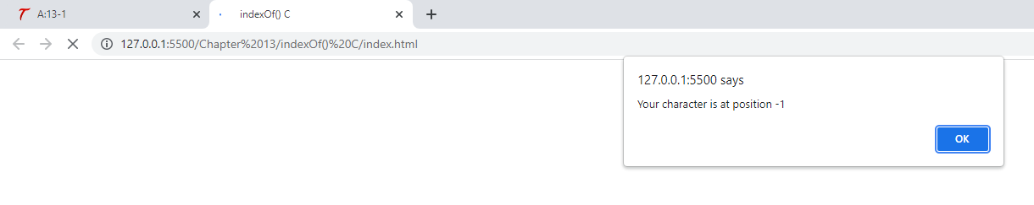

<!DOCTYPE html>

<html lang="en">

<head>

    <title>indexOf() C</title>

</head>

<body>

    <script src="app.js"></script>

</body>

</html>

let the_text = "Cool";

let position = the_text.indexOf("c");

alert("Your character is at position " + position);

**Page 365 Position –1**

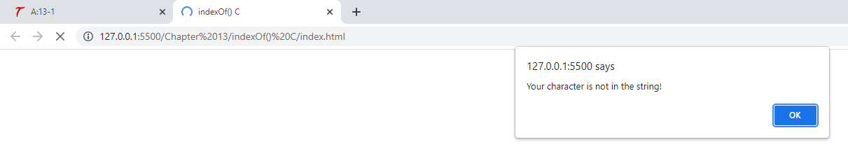

<!DOCTYPE html>

<html lang="en">

<head>

    <title>indexOf() C</title>

</head>

<body>

    <script src="app.js"></script>

</body>

</html>

let the_text = "Cool";

let position = the_text.indexOf("c");

if (position === -1) {

    alert("Your character is not in the string!");

} else {

    alert("Your character is at position " + position);

}

**Page 365 indexOf() – o**

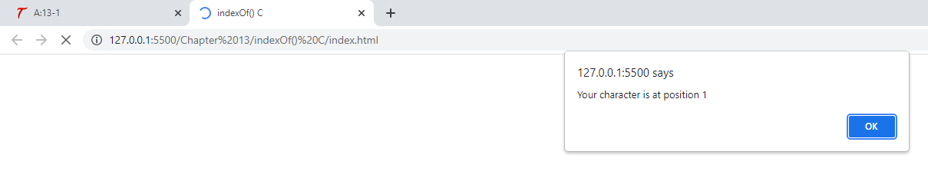

<!DOCTYPE html>

<html lang="en">

<head>

    <title>indexOf() C</title>

</head>

<body>

    <script src="app.js"></script>

</body>

</html>

let the_text = "Cool";

let position = the_text.indexOf("o");

if (position === -1) {

    alert("Your character is not in the string!");

} else {

    alert("Your character is at position " + position);

}

**Page 366 indexOf() – o, 2**

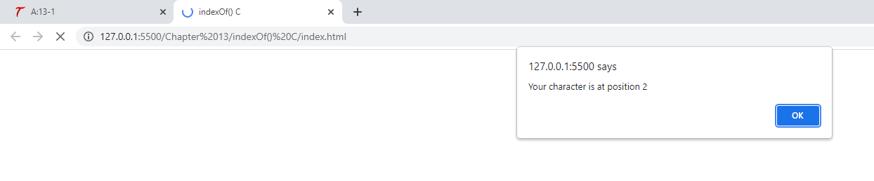

<!DOCTYPE html>

<html lang="en">

<head>

    <title>indexOf() C</title>

</head>

<body>

    <script src="app.js"></script>

</body>

</html>

let the_text = "Cool";

let position = the_text.indexOf("o", 2);

if (position === -1) {

    alert("Your character is not in the string!");

} else {

    alert("Your character is at position " + position);

}

**Page 366 lastindexOf()**

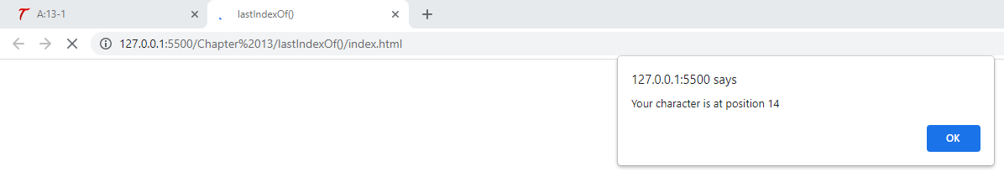

<!DOCTYPE html>

<html lang="en">

<head>

    <title>lastIndexOf()</title>

</head>

<body>

    <script src="app.js"></script>

</body>

</html>

let the_text = "Cool Cruising Car";

let position = the_text.lastIndexOf("C");

alert("Your character is at position " + position);

**Page 367 split()**

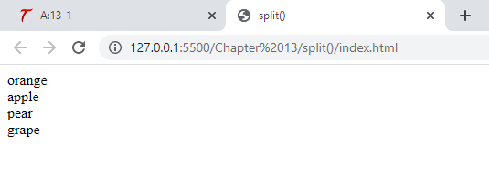

<!DOCTYPE html>

<html lang="en">

<head>

    <title>split()</title>

</head>

<body>

    <script src="app.js"></script>

</body>

</html>

let the_text = "orange:apple:pear:grape",

    split_text = the_text.split(":"),

    end_count = split_text.length;

for (let count = 0; count < end_count; count++) {

    document.write(split_text[count] + "<br>");

}

**Page 368 toLowerCase()**

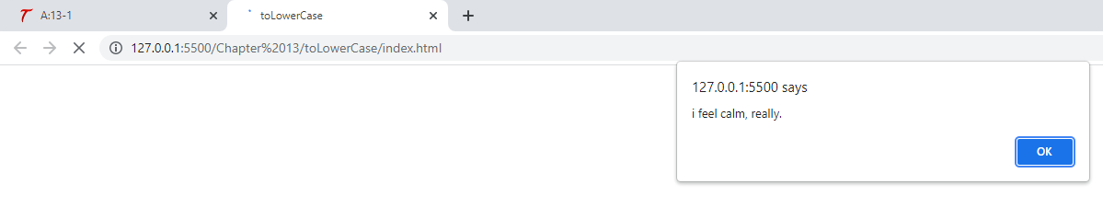

<!DOCTYPE html>

<html lang="en">

<head>

    <title>toLowerCase</title>

</head>

<body>

    <script src="app.js"></script>

</body>

</html>

let the_text = "I FEEL CALM, REALLY.";

alert(the_text.toLowerCase());

**Page 368 toUpperCase()**

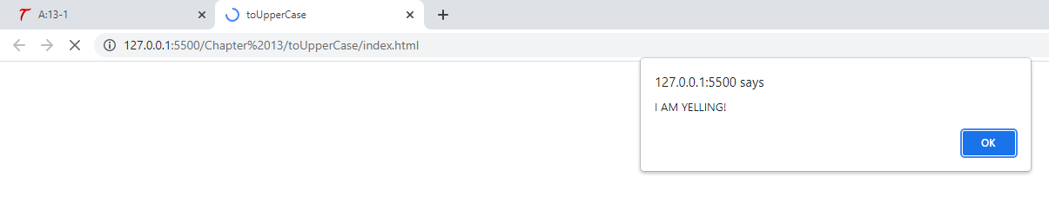

<!DOCTYPE html>

<html lang="en">

<head>

    <title>toUpperCase</title>

</head>

<body>

    <script src="app.js"></script>

</body>

</html>

let the_text = "I am yelling!";

alert(the_text.toUpperCase());

**Page 368 trim()**

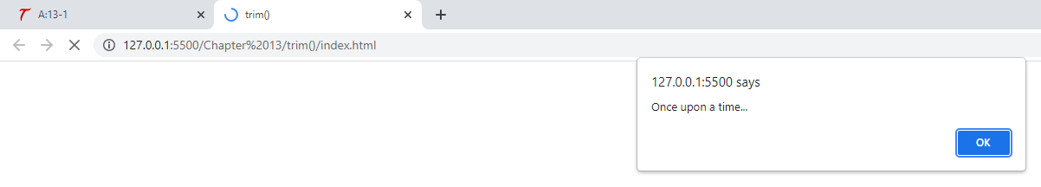

<!DOCTYPE html>

<html lang="en">

<head>

    <title>trim()</title>

</head>

<body>

    <script src="app.js"></script>

</body>

</html>

let text = "   Once upon a time...  ",

    trimmed_text = text.trim();

alert(trimmed_text);

**Page 370 Try This 13-1**

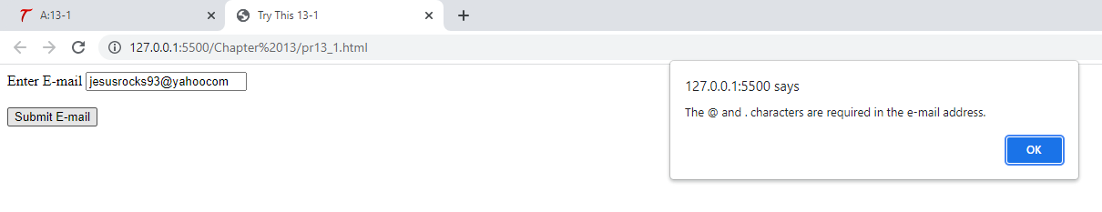

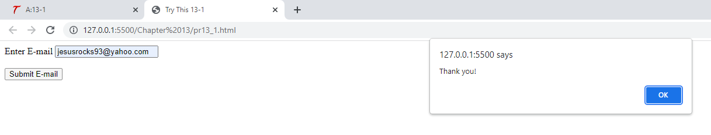

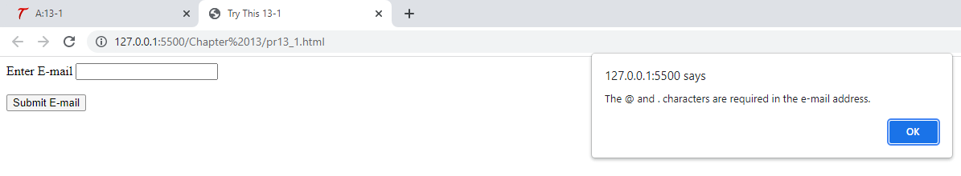

<!DOCTYPE html>

<html lang="en">

<head>

    <meta charset="UTF-8">

    <meta http-equiv="X-UA-Compatible" content="IE=edge">

    <meta name="viewport" content="width=device-width, initial-scale=1.0">

    <title>Try This 13-1</title>

</head>

<body>

    <form id="getemail">

        <label for="email">Enter E-mail</label>

        <input type="text" id="email"><br><br>

        <input type="submit" value="Submit E-mail">

    </form>

    <script src="prjs13_1.js"></script>

</body>

</html>

let getemail = document.getElementById("getemail");

getemail.addEventListener("submit", function(event) {

    let email_add = document.getElementById("email").value;

    event.preventDefault();

    if ((email_add.indexOf("@") >= 0) && (email_add.indexOf(".") >= 0)) {

        alert("Thank you!");

    } else {

        alert("The @ and . characters are required in the e-mail address.");

    }

}, false);

**Page 376 Try This 13-2**

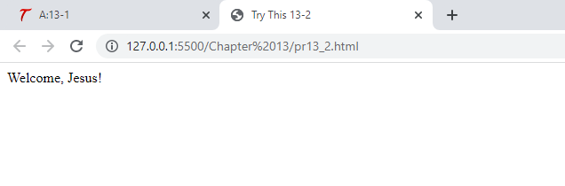

<!DOCTYPE html>

<html lang="en">

<head>

    <meta charset="UTF-8">

    <meta http-equiv="X-UA-Compatible" content="IE=edge">

    <meta name="viewport" content="width=device-width, initial-scale=1.0">

    <title>Try This 13-2</title>

</head>

<body>

    <script src="prjs13_2.js"></script>

</body>

</html>

function set_it() {

    let user_input = prompt("Enter your name", ""),

        test1 = "name=" + encodeURIComponent(user_input),

        expdate = ";expires=Tue, 30 Nov 2021 13:00:00 UTC";

    test1 += expdate;

    document.cookie = test1;

}

function read_it() {

    let mycookie = document.cookie,

        cookiename = mycookie.split("=");

    document.write("Welcome, " + decodeURIComponent(cookiename[1]) + "!");

}

if (document.cookie) {

    read_it();

} else {

    set_it();

    read_it();

}

**Page 379 test()**

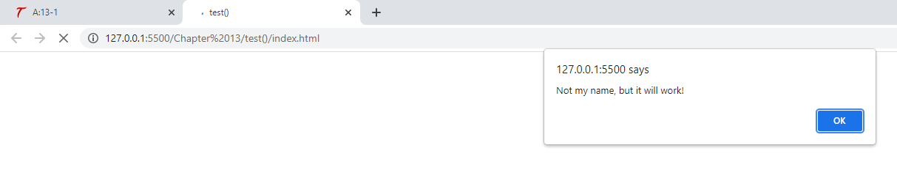

<!DOCTYPE html>

<html lang="en">

<head>

    <meta charset="UTF-8">

    <meta http-equiv="X-UA-Compatible" content="IE=edge">

    <meta name="viewport" content="width=device-width, initial-scale=1.0">

    <title>test()</title>

</head>

<body>

    <script src="app.js"></script>

</body>

</html>

let thename = prompt("Enter your name", ""),

    tomatch = /John/,

    is_a_match = tomatch.test(thename);

if (is_a_match) {

    alert("Wow, we have the same name!");

} else {

    alert("Not my name, but it will work!");

}

**Page 380 test – flag**

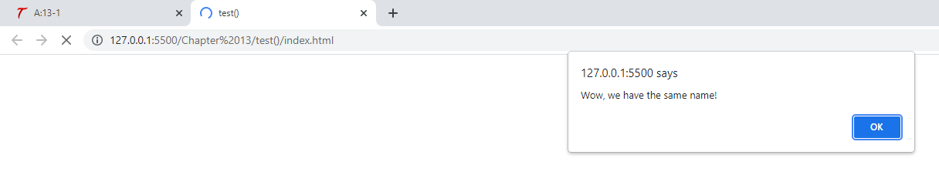

<!DOCTYPE html>

<html lang="en">

<head>

    <meta charset="UTF-8">

    <meta http-equiv="X-UA-Compatible" content="IE=edge">

    <meta name="viewport" content="width=device-width, initial-scale=1.0">

    <title>test()</title>

</head>

<body>

    <script src="app.js"></script>

</body>

</html>

let thename = prompt("Enter your name", ""),

    tomatch = /John/i,

    is_a_match = tomatch.test(thename);

if (is_a_match) {

    alert("Wow, we have the same name!");

} else {

    alert("Not my name, but it will work!");

}

**Page 383 more than one digit**

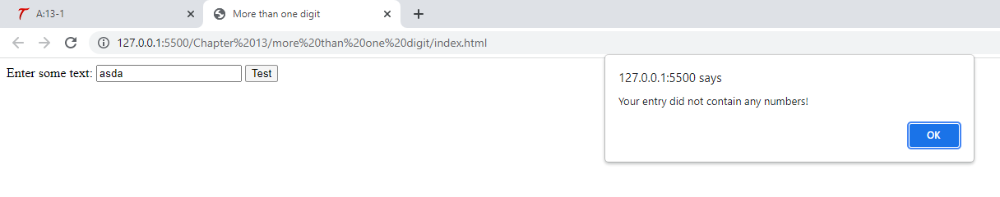

<!DOCTYPE html>

<html lang="en">

<head>

    <meta charset="UTF-8">

    <meta http-equiv="X-UA-Compatible" content="IE=edge">

    <meta name="viewport" content="width=device-width, initial-scale=1.0">

    <title>More than one digit</title>

</head>

<body>

    <form id="has_digits">

        <label for="user_text">Enter some text:</label>

        <input type="text" id="user_text">

        <input type="submit" value="Test">

    </form>

    <script src="app.js"></script>

</body>

</html>

let has_digits = document.getElementById("has_digits");

has_digits.addEventListener("submit", function(event) {

    let has_num = document.getElementById("user_text").value,

        tomatch = /\d+/;

    event.preventDefault();

    if (tomatch.test(has_num)) {

        alert("Your entry contained one of more numbers!");

    } else {

        alert("Your entry did not contain any numbers!");

    }

}, false);

**Page 385 replace() skunk one instance**

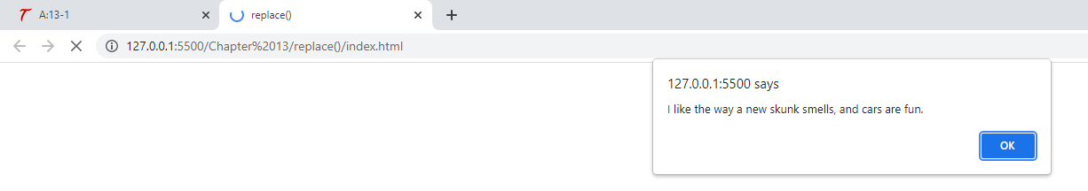

<!DOCTYPE html>

<html lang="en">

<head>

    <meta charset="UTF-8">

    <meta http-equiv="X-UA-Compatible" content="IE=edge">

    <meta name="viewport" content="width=device-width, initial-scale=1.0">

    <title>replace()</title>

</head>

<body>

    <script src="app.js"></script>

</body>

</html>

let mystring = "I like the way a new car smells, and cars are fun.",

    toreplace = /car/,

    newstring = mystring.replace(toreplace, "skunk");

alert(newstring);

**Page 385 replace() all instances**

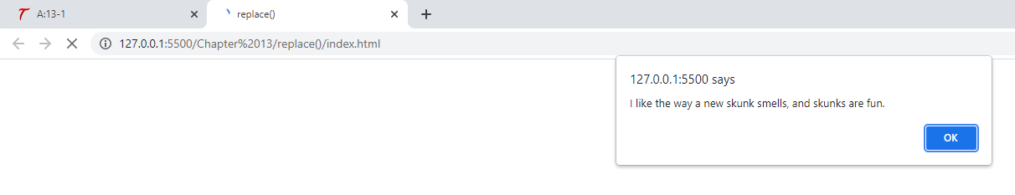

<!DOCTYPE html>

<html lang="en">

<head>

    <meta charset="UTF-8">

    <meta http-equiv="X-UA-Compatible" content="IE=edge">

    <meta name="viewport" content="width=device-width, initial-scale=1.0">

    <title>replace()</title>

</head>

<body>

    <script src="app.js"></script>

</body>

</html>

let mystring = "I like the way a new car smells, and cars are fun.",

    toreplace = /car/g,

    newstring = mystring.replace(toreplace, "skunk");

alert(newstring);

**Page 385 replace() add z to name**

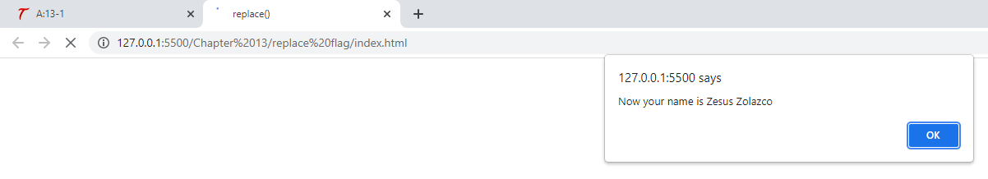

<!DOCTYPE html>

<html lang="en">

<head>

    <meta charset="UTF-8">

    <meta http-equiv="X-UA-Compatible" content="IE=edge">

    <meta name="viewport" content="width=device-width, initial-scale=1.0">

    <title>replace()</title>

</head>

<body>

    <script src="app.js"></script>

</body>

</html>

function getname() {

    let tomatch = /^[A-Za-z]+\s[A-Za-z]+$/,

        toreplace = /\b[A-Za-z]/gi,

        thename = prompt("Enter your first and last name", "");

    if (tomatch.test(thename)) {

        newname = thename.replace(toreplace, "Z");

        alert("Now your name is " + newname);

    } else {

        alert("Name invalid. Please Try Again");

        getname();

    }

}

getname();

**Page 387 search()**

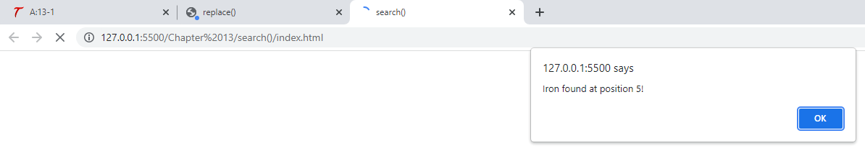

<!DOCTYPE html>

<html lang="en">

<head>

    <meta charset="UTF-8">

    <meta http-equiv="X-UA-Compatible" content="IE=edge">

    <meta name="viewport" content="width=device-width, initial-scale=1.0">

    <title>search()</title>

</head>

<body>

    <script src="app.js"></script>

</body>

</html>

let mystring = "I am Ironman!",

    tomatch = /Iron/;

if (mystring.search(tomatch)) {

    alert("Iron found at position " + mystring.search(tomatch) + "!");

} else {

    alert("Sorry, no Iron in your string.");

}